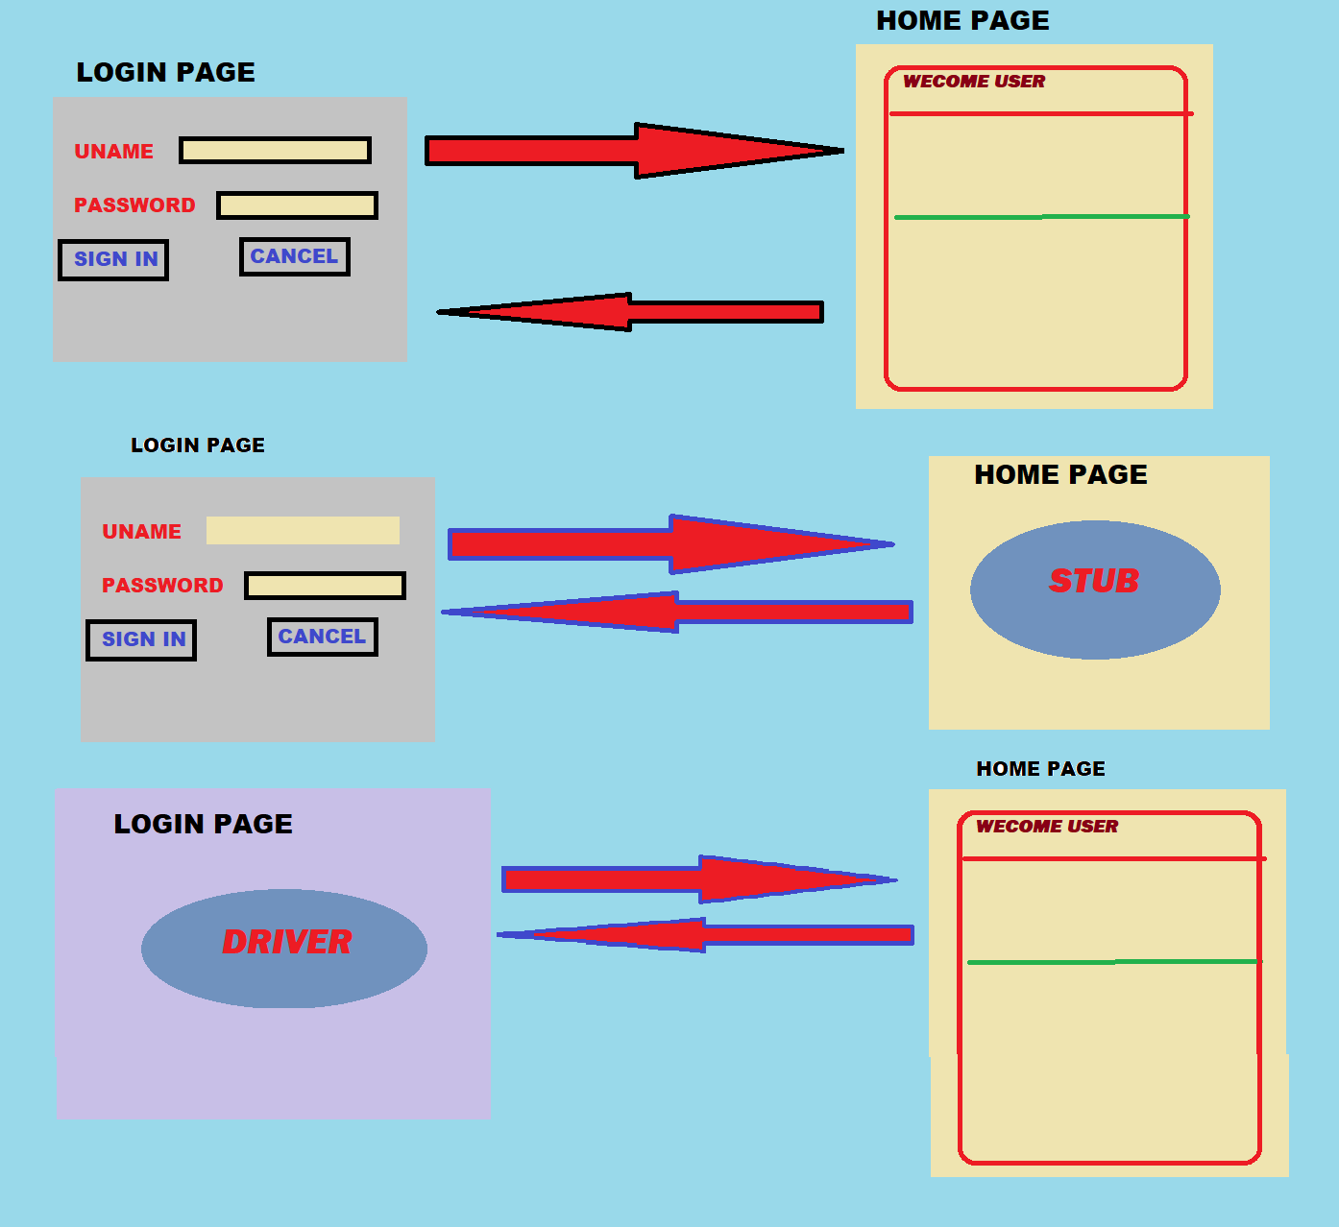

Suppose you have two pages

* LOGIN PAGE
* HOME PAGE

First developer is working Login page

Second developer is working Home page

* **Requirement:**

When you enter valid credentials in login page it should land in home page

**Two cases**

* **case 1**

First developer has finished login page but home page is not completed but login page need to be tested

* **case 2**

Second Developer has finished home page but login page is not completed home page is need to be tested